**Releases:**

**Creating a release:**

* We have two steps here. One is **“artifacts”** and another is **“stages”**

**Artifacts:**

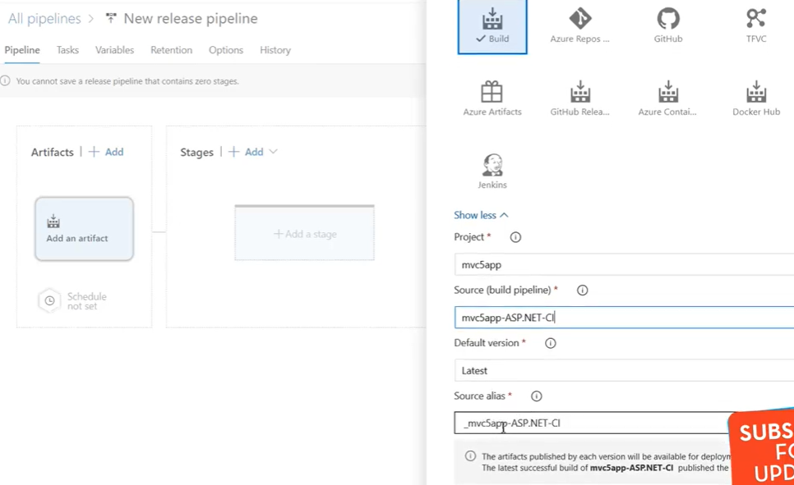

* In artifacts step, we need to select where we need to take the artifacts from and we can give any alias name we want.
* We can either take from build jobs, code repo, github, ACR, docker hub etc..

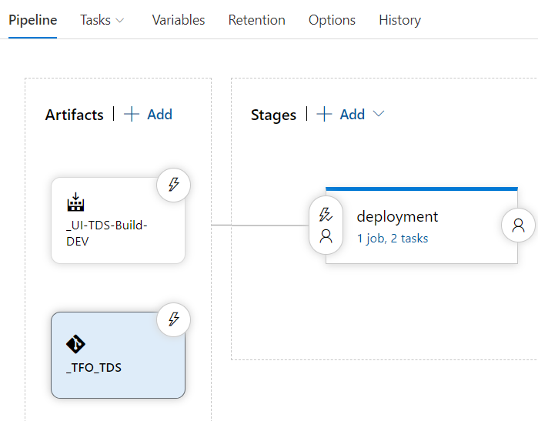

* We may also need to add the repo if we are using any file or something in stages from the repo.

**Stages:**

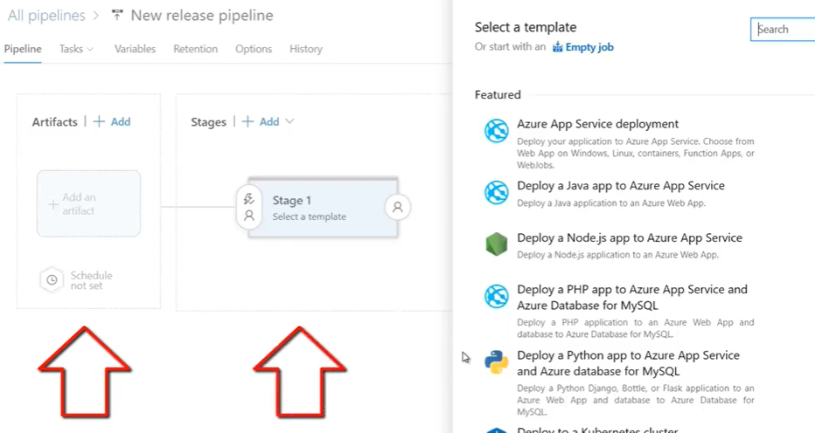

* Now in stages, we can have an empty job or with the template and give a name to the stage.
* Inside the stage, it will be same as pipeline. We can have agent jobs and steps inside that as below.

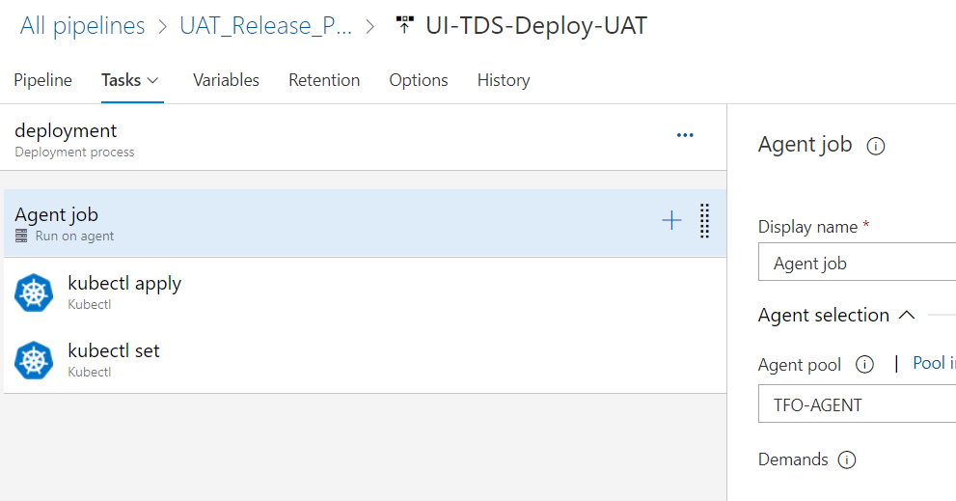

**Variables:**

* Variables option will be same as pipelines. We can add any variables here or use default system variables.

**Retention:**

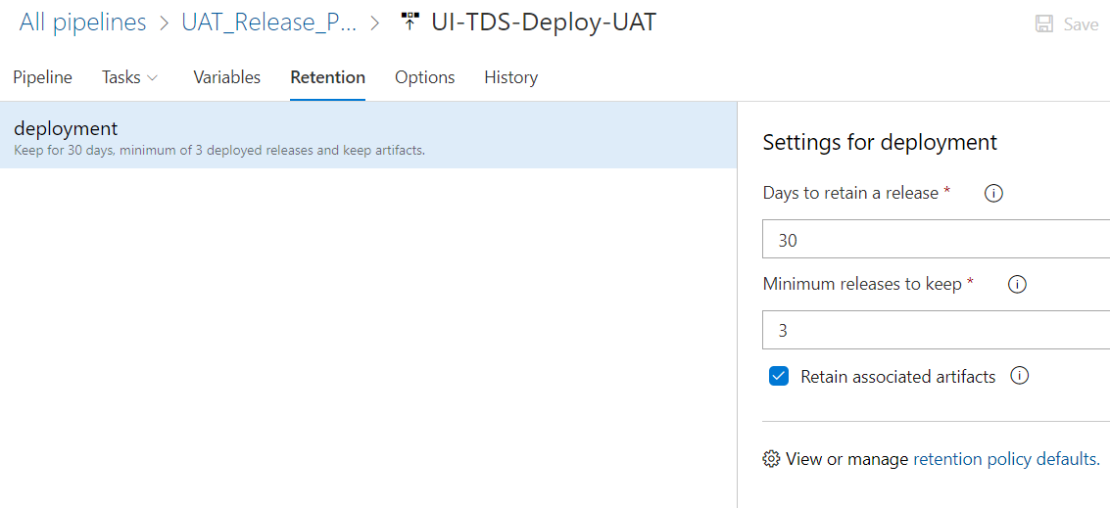

* We can also modify these in project settings.

**Options:**

* Below are the options we have in releases.

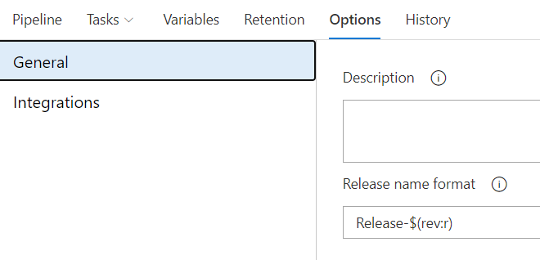

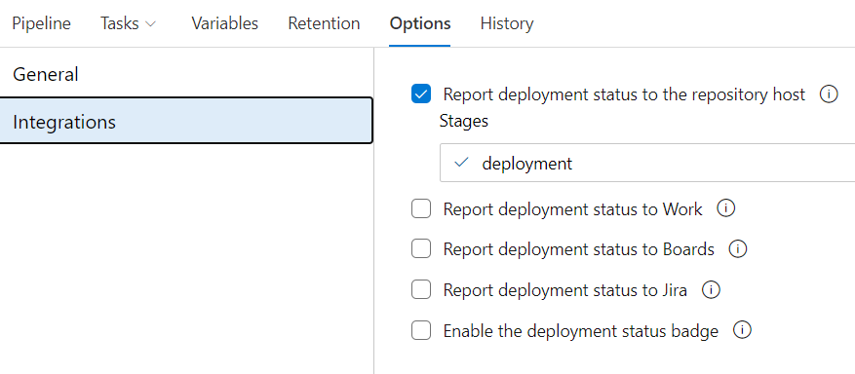

**Continuous deployment trigger:**

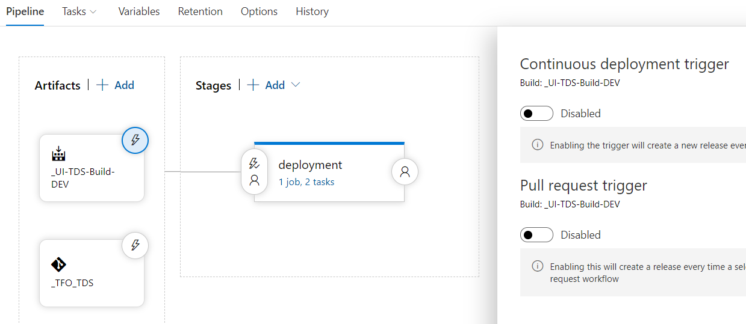

* If we select **“continuous deployment trigger”** option on the artifact as above. We can enable CD whenever new build is available or new pull request available

**Pre deployment conditions:**

* We have below pre-deployment conditions on releases.

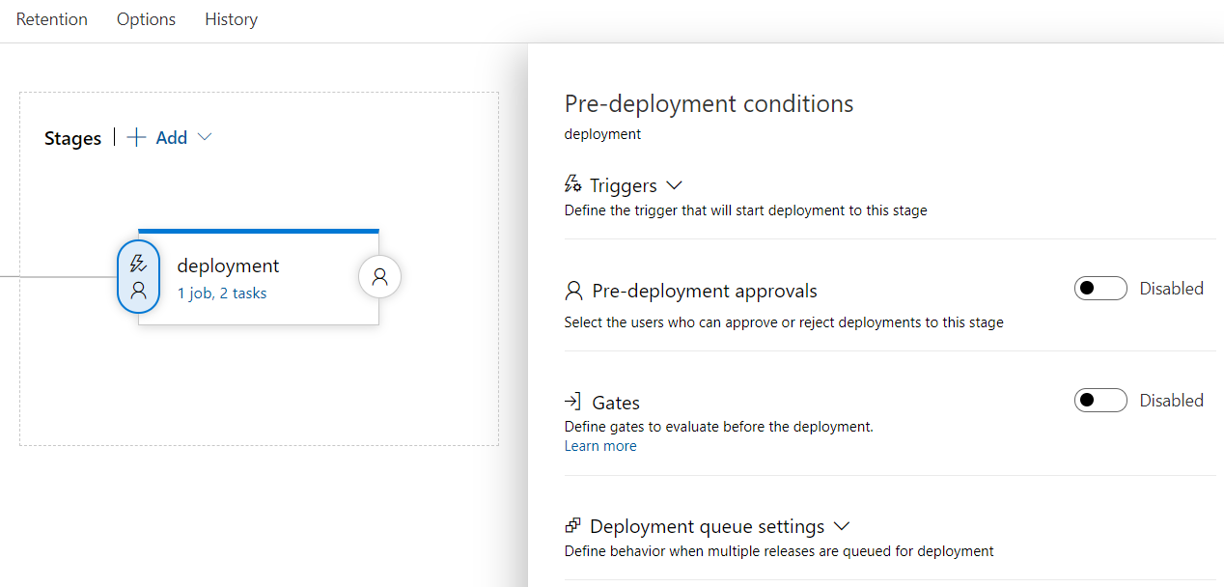

**Triggers:**

* Here we can simple manually option also or we can select “after release” option to get three more options as below.

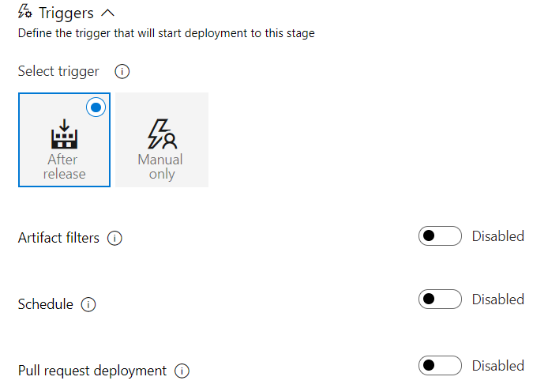

**Artifact filters:**

* Here, release will be triggered only if the given condition is passed with the branch as below.

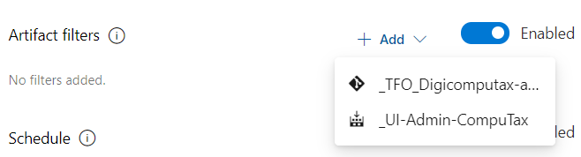

* We can pass the condition with any of the artifact as above.

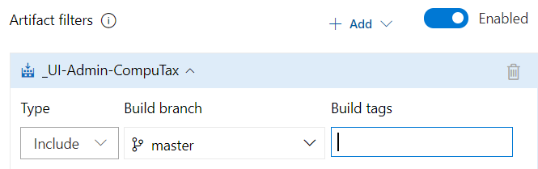

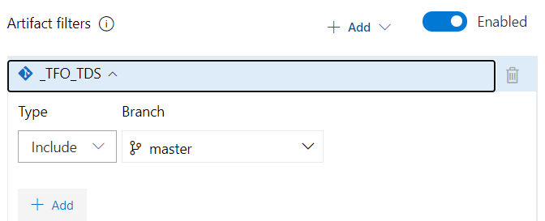

* We can add the conditions as above to trigger the job only if the artifact is from given branch or with given tags

**Schedule:**

* This is to trigger the release as scheduled.

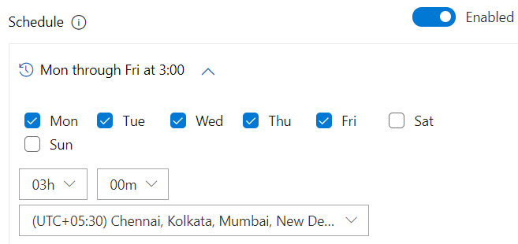

**Pull request:**

* This will enable to trigger the release based on the pull request.

**Pre deployment approvals:**

* We can add users or groups to approves the release

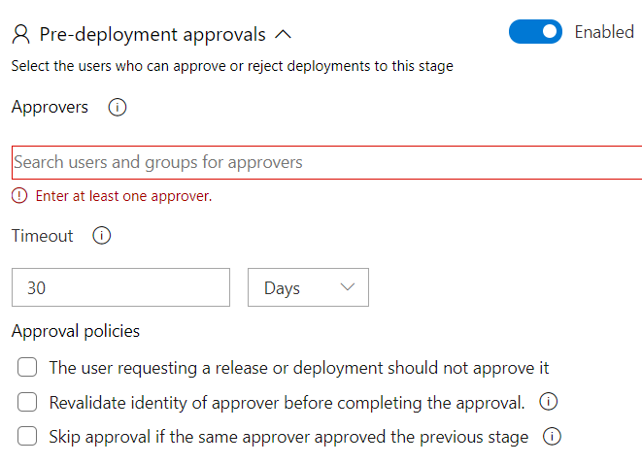

**Deployment queue settings:**

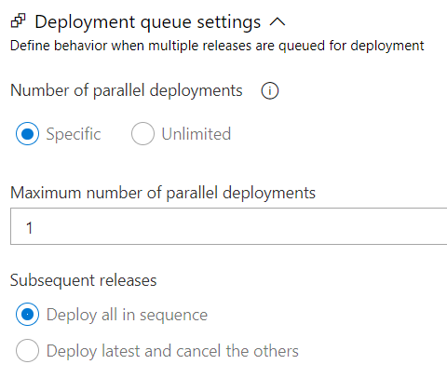

* We can give specific parallel deployments can be triggered at a time here. Also, we can select to deploy all in sequence or to deploy latest and cancel the remaining option as above.
* Or we can simply select the unlimited option.

**Post deployment conditions:**

* We have below **“post deployment conditions”** in releases.

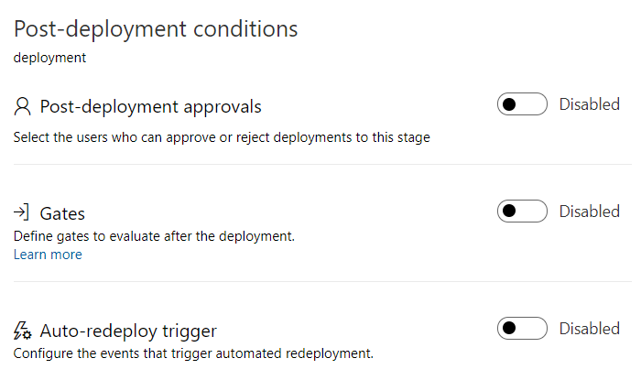

**Post-deployment approvals:**

* We can add approvers to approve or reject the release at this stage

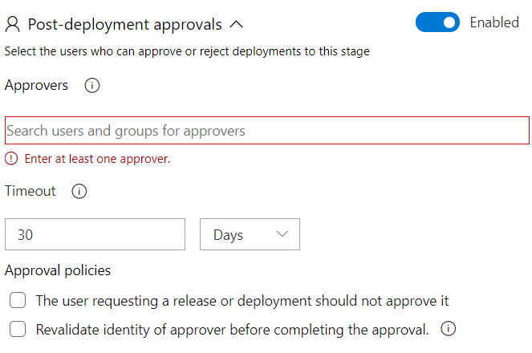

**Auto redeploy trigger:**

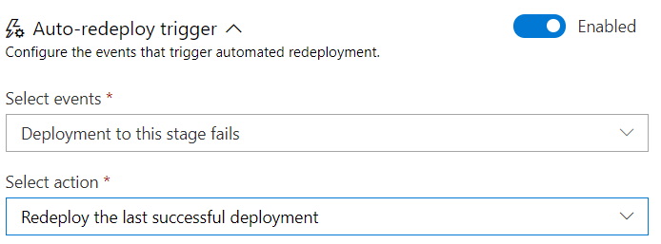

* We can select above events and action to redeploy the last successful deployment automatically if this stage fails.

**More options:**

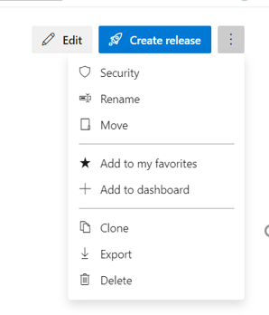

* Here, we can rename, move, clone, export/import, delete options works same as in pipelines.
* Below are the permissions we can give under “security” option.

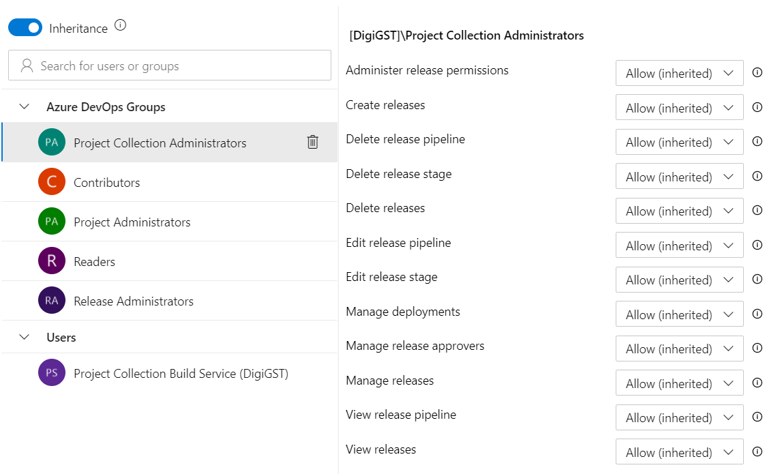

**Releases options:**

* We can see the below options if we open any release

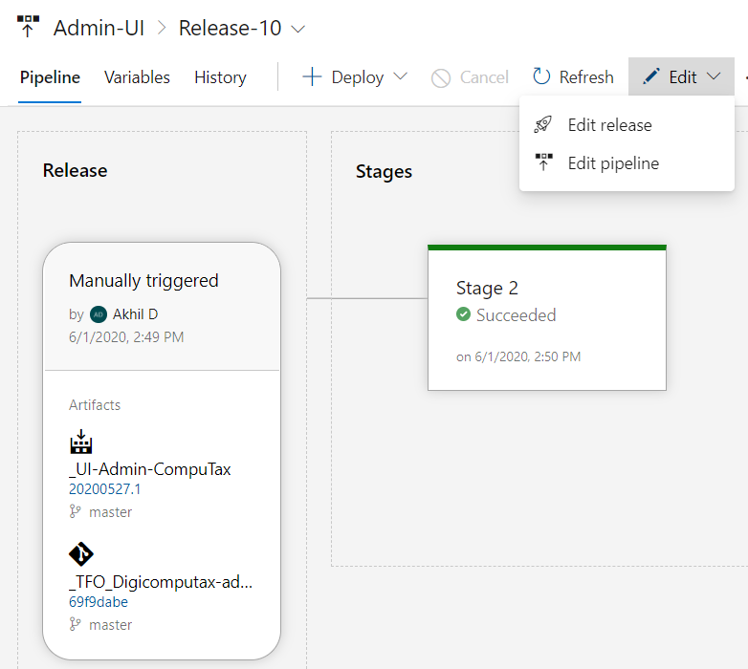

* We can either edit the while pipeline or we can just edit the release

**Here also we can add security to all releases at once like pipelines**

**We can rename, delete or add security to the folders as well.**